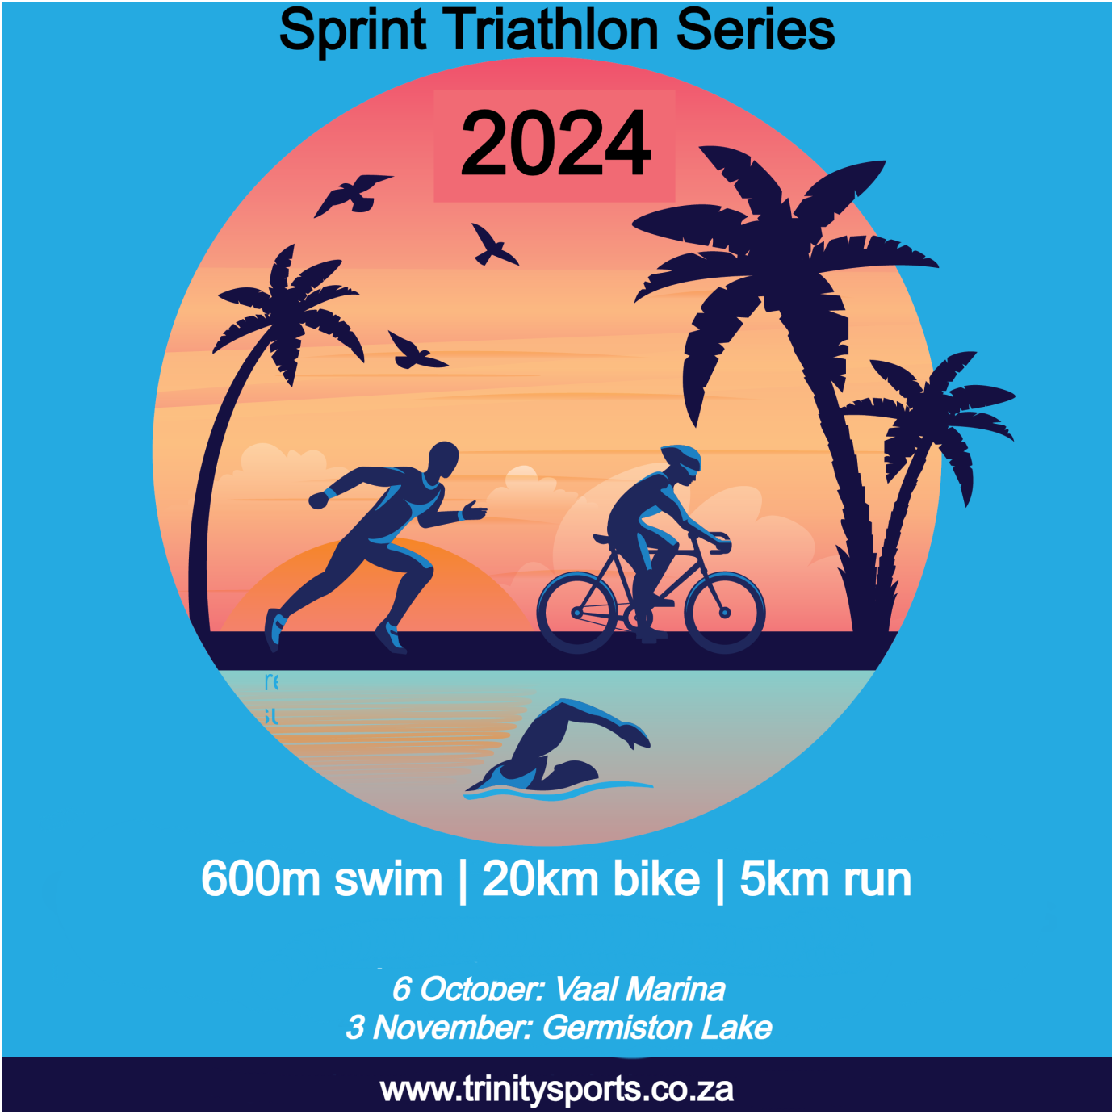

**OVERVIEW**

Dive into Vaal Marina's allure with a scenic course embracing the town's lakeside spirit. Conclude the series at Germiston Lake where urban vibrancy meets athletic triumph.

Each destination is a unique chapter, weaving together the thrill of competition, community celebration, and the spirit of adventure. Don't miss the chance to make your mark – enter the series and experience the magic of Vaal Marina and Germiston Lake!

Race as an individual, or complete the challenge as a member of a 2 person or 3 person relay team.

**HOW IT WORKS**

Click the DETAILS button next to each date to get an overview of the race. You can find relevant details for each race (course routes, race schedule, athlete guide & race day parking) under its section as it becomes available. From there you’ll be able to enter a race.

**RACE TYPES**

Athletes can do the entire race on their own as an individual (solo) or take part as a member of a relay team.

A team can consist of 2 or 3 team members. **Each team member must be 16 years or older on the date of the race (no exceptions allowed)**.

2 person team – 1 person does 2 disciplines, and 1 person does 1 discipline.

3 person team – each person does 1 discipline.

NOTE: the team race is a relay race. Team members work together to complete the race. Each team member does not do the whole race.

**RACE AGE**

Each participant must be at least 16 years old on the day of a race (including each member of a team). This applies without exception.

**BIKES ALLOWED**

Any standard road bike or mountain bike is allowed.

Time trial (TT) bikes are not allowed.

Aero bars/tri bars (regardless of length) are not allowed.

**RACE DISTANCE**

Sprint triathlon: 600m swim / 20km bike / 5km run

**COST**

|  |  |
| --- | --- |
| **RACE TYPE** | **COST** |
| SOLO (AGES 16+) | R400* |
| TEAM OF 2 PERSONS (AGES 16+) | R550* |
| TEAM OF 3 PERSONS (AGES 16+) | R650* |
| TIMING CHIP (ONCE OFF COST) | R50** |

* Cost excludes a Triathlon South Africa (TSA) day licence of R50 per person (if you don’t have a current TSA licence for the 2024 season).

** A compulsory race chip must be bought once for the whole series (and other Trinity Sports races).

**EARLY BIRD ENTRIES**

Enter and pay for the entire series during the month of February (1-29 February 2024) and get a discount of **10% off the entry fee**!

We’ve created custom designed socks for the 2024 series with The Sox Factory. The first 350 entries will receive a complimentary pair of these uber socks valued at R180. These socks will not be for sale – you can only get them if you enter early!

**DATES**

**DETAILS**

**6 October 2024 – Vaal Marina**

**DETAILS**

**3 November 2024 – Germiston Lake**

**SERIES POINTS**

It’s a series, which means we must determine who the best male, female and team athletes are! Points per race are awarded as follows:

|  |  |
| --- | --- |
| **PLACE** | **POINTS** |
| 1st | 10 |
| 2nd | 9 |
| 3rd | 8 |
| 4th | 7 |
| 5th | 6 |
| 6th | 5 |
| 7th | 4 |
| 8th | 3 |
| 9th | 2 |
| 10th | 1 |

**BONUS POINTS\***

|  |  |
| --- | --- |
| **ACTIVITY** | **POINTS** |
| Fastest swim time | 1 |
| Fastest bike time | 1 |
| Fastest run time | 1 |
| Sub 60 min. race | 1 |

**\*** bonus points are only awarded if the athlete places in the top 10 male/top 10 female

Examples

John finishes the race in 3rd place. His time was 59m18s. He had the fastest swim time of all males in the race.

Points awarded

|  |  |
| --- | --- |
| **ACTIVITY** | **POINTS** |
| 3rd place male | 8 |
| Fastest swim time | 1 |
| Sub 60 min. race | 1 |
| **TOTAL** | **10** |

Nomsa finishes the race in 2nd place. Her time was 60m25s. She had the fastest run time of all females in the race.

Points awarded

|  |  |
| --- | --- |
| **ACTIVITY** | **POINTS** |
| 2nd place female | 9 |
| Fastest run time | 1 |
| **TOTAL** | **10** |

Pieter finishes the race in 11th place. His time was 68m25s. He had the fastest bike time of all males in the race.

Points awarded

|  |  |
| --- | --- |
| **ACTIVITY** | **POINTS** |
| 11th place male | 0 |
| Fastest bike time | 0 |
| **TOTAL** | **0** |

Although he had the fastest bike time, Pieter didn’t finish in the top 10 males and thus the bonus point does not apply.

**DISPUTES**

We’ll allow 20 minutes from the time an athlete finishes for a dispute to be lodged. Once investigated, the race referee’s decision is final and binding.

**PRIZES**

Prizes categories:

* Top 10 males
* Top 10 females
* Top 5 male teams (the team consists of only males)
* Top 5 female teams (the team consists of only females)
* Top 5 mixed teams (the team consists of both male & female athletes)

Category prize eligibility: athletes must at least start every race to be eligible to receive a category prize. Example: if an athlete is placed overall second on points after 2 races, but doesn’t at least start the Germiston Lake race, that athlete will not be eligible for a category prize. **This is non-negotiable**.

There are no age group category prizes. We’ll have a lucky draw where everyone has a chance to win.

We’ll update this section closer to the race. Keep an eye on our website!

**SHOWDOWN**

The top 10 males, top 10 females, top 5 male teams, top 5 female teams and top 5 mixed teams on points after finishing the Germiston Lake race, will face off in a super sprint race at Germiston Lake on 3 November 2024. There will be additional prizes up for grabs in the Showdown race.

We’ll update this section closer to the race. Keep an eye on our website!

**VAAL MARINA**

A hidden gem waiting to be explored! Imagine a swim in the glistening waters of the Vaal Dam, setting the stage for an epic journey. The town's unique blend of tranquility and vibrancy ensures an experience like no other. Join us on 6 October and become part of the story that Vaal Marina is waiting to tell. Don't miss the chance to create memories and share in the allure of this lakeside escape – the race of a lifetime awaits!

**ENTER RACE**

Course Routes

Race Schedule

Athlete Guide

Race Parking

**GERMISTON LAKE**

Dive into the pristine waters of Germiston Lake, setting the stage for a cycle around the lake and running in the park. Imagine the rush of triumph as you cross the finish line against the backdrop of this urban oasis. Join us on 3 November for a chance to immerse yourself in the dynamic energy of Johannesburg. Don't miss out on the adventure that awaits – Germiston Lake is calling!

**ENTER RACE**

Course Routes

Race Schedule

Athlete Guide

Race Parking