If The Shoe Doesn’t Fit… 14 May 2013
A minority of runners have very specific needs, which can make shoe buying an altogether more frustrating business. If you’re a forefoot striker, a heel striker, an under-pronater, wear orthotics, or have very wide or very narrow feet, you’re in the minority.
Here’s the type of shoe you should wear:
What shoe should you wear...
- If you’re a Forefoot Striker
You… land and push off from your toes when you run, rather than following the normal pattern of landing on the outside edge of your heel and rolling through to push off from your toes.
You need shoes that… have excellent forefoot cushioning, flexibility and stability. However, you need to have an expert assess precisely why you’re a forefoot striker. If it’s because you have a high arch and a rigid ankle, you need a neutral, relatively curved shoe to encourage foot motion, with a flexible forefoot and a high arch support.
If you’re a forefoot striker simply because you have tight calves, you should address this problem with stretching and/or physiotherapy rather than trying to compensate via your shoes.
Finally, some runners favour the forefoot simply because they run quickly; they need light, responsive shoes, with an emphasis on forefoot cushioning and stability.
- If You’re a heel Striker
You… prematurely destroy the outsole rubber (and probably the cushioning) on the outside heel of your shoes. This is usually because you land in an exaggerated way; though if you’re heavy, that could also contribute.
You need shoes that… have thick, durable outsoles and resilient midsole foam. Because the composition of the outsole compound is at least as important as its thickness, you need to know about a shoe’s reputation before you buy. Ask your local specialist retailer, or check out Runner’s World for regular shoe tests and expert opinion on the latest ranges.
- If you under pronate
Your… feet and ankles don’t roll inwards enough when you run, a movement that would normally help to absorb shock every time your feet strike the ground. This is a rare condition, and certainly less common than excessive roll (overpronation) but there are shoes to help overcome the problem.
You need shoes that… encourage the inward movement of the foot (pronation). Look for a soft midsole, and a curved ‘last’ (the shape around which the shoe is built).
Avoid shoes with added stability features, such as medial posts. These are firm sections on the arch side of the midsole, designed to limit lateral movement for those runners who overpronate.
- If you wear orthoses
You… have custom-made insoles designed to correct biomechanical imbalances. They are usually – but not always – built to provide additional stability.
You need shoes that… fit your orthoses, and work with them in the way that your podiatrist intended. Usually, if your orthoses provide all the correction you need, your podiatrist is likely to recommend using them in a neutral but supportive shoe. Extreme over-pronators may be recommended a motion-control shoe; especially as (in the view of many leading podiatrists) the chance of having too much stability is slim.
In either case, look for shoes that are roomy enough to accommodate orthoses comfortably. Look particularly for a deep heel counter, as built-up orthoses can compromise stability and comfort in shallow-fitting shoes.
- If you have wide feet
You… are not alone. As more runners get specialist advice and gait analysis, so more manufacturers now offer a growing range of shoes to cater for the specific needs of those with wide feet.
You need shoes that… keep pressure off the sides of your feet, and allow the recommended thumb’s width of space between your longest toe and the end of the shoe.
Beware, though. Finding the right shoe isn’t simply a matter of reaching for the nearest available option in a wide fit. It actually depends on why your feet are wide relative to their length (it also has to meet your stability and cushioning needs). If you have short toes, you’ll need a shoe that flexes further forward than normal because relatively speaking, that’s what your feet do. You retailer will look for the position of the flex grooves on the underside of the shoe to help you avoid a retail blunder here.
- If you have narrow feet
You… need to do more than just lace up normal shoes tightly.
You need shoes that… don’t allow your feet to slip inside. Not only will over-wide shoes feel less responsive, you’ll also be more at risk of blisters in the areas where your feet do touch the shoe, because you’ll be sliding around. As with the wider fits, most manufacturers have woken up to the fact that not everyone has standard-sized or -shaped feet, and they now offer narrow options.
It may be coincidence, but you could turn out to be really fast, because often the best narrow-fit running shoes fall into the performance category…

Choose Your Shoe 6 November 2012
There’s no such thing as the ‘best’ shoe – everyone has different needs. Biomechanics, body weight, the surfaces you run on and the shape of your feet mean one person’s ideal is someone else’s nightmare.
Here’s how to avoid the pitfalls,
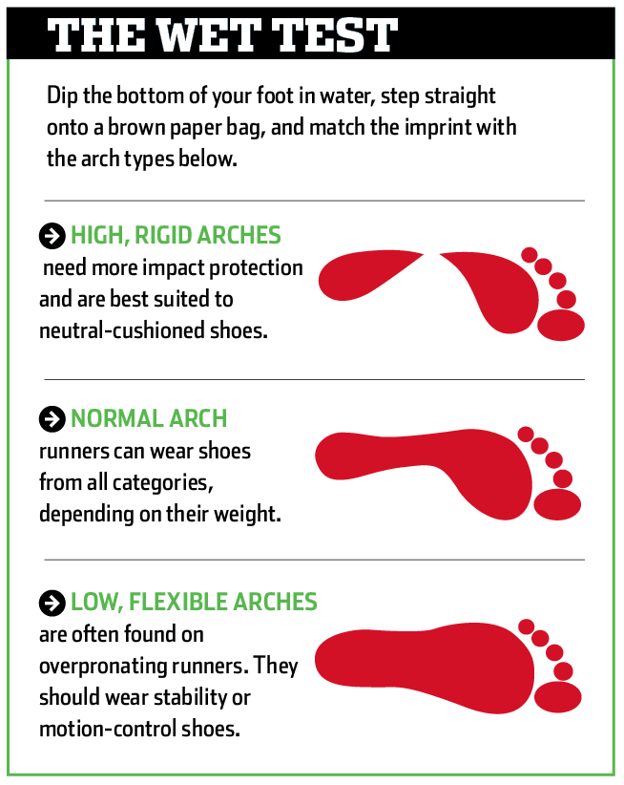
Shoes can be divided into four main categories – neutral cushioned, motion-control, stability and performance – which, for all the bright colours and crazily named hi-tech features, are basically designed to suit different people’s biomechanical needs.
The first step in finding your ideal shoe needs is to try our ‘wet test’. This works on the basis that the shape of your wet footprint roughly correlates with the amount of stability you might need in your shoe. ‘Roughly’ is the key word here, though: it’s a handy starting point, but no more than that.
Second, read the section on shoe categories for a greater understanding of the four types on offer. And once you’ve done that, and got at least some idea of what type of shoe will suit you best, visit a biomechanics expert – or, more realistically, an experienced specialist running shop – to get a ‘gait analysis’ done. This is a more scientifically advanced version of the wet test, in which a specialist will look at how your foot strikes the ground to help choose a shoe with the right levels of support.
One fit never fits all.
With the right advice, most runners will find it relatively easy to find a shoe that is at least close to ideal.
Once you’ve determined which category you fall into, you have a wide range of shoes to choose from. All you have to do is decide which shoe within your category provides the best comfort, fit and performance for your needs – although that can be a daunting prospect for a beginner.
Try out a range of shoes, listen to the advice and don’t rush into a decision if you’re unsure.
Some people, however, have problems finding a comfortable shoe at all. A minority of runners have very specific needs, which can make shoe buying an altogether more frustrating business. If you’re a forefoot striker, a heel striker, an under-pronater, wear orthotics, or have very wide or very narrow feet, you’re in the minority.

Shinsplints 14 January 2013
‘Shin splints’ refers to medial tibial stress syndrome, an achy pain that results when small tears occur in the muscles around your tibia (shin bone). This makes up about 15% of running injuries.
Who’s at risk?
Shin splints are common among new runners and those returning after an extended lay-off. They’re a sign that you’ve done too much too quickly. Shin splints strike runners wearing the wrong shoe or a pair with too many kilometers, and those with high arches or flat feet.
Can you run through it?
When the first twinges of pain strike, back off your running to a comfortable level for a few days to a week, then slowly up your mileage using the 10% rule – no more than a 10% increase per week). Bike, pool-run, and swim.
Rehab it
Rest, ice, and ibuprofen can ease the pain. Though conventional wisdom has preached calf stretching as a way to rehabilitate shin splints, there’s little evidence that helps. Taping the shin with Kinesio Tex tape can relieve pain and speed healing. Wearing an air-cast ankle brace throughout the day, even while running, can speed recovery. These braces stabilise the ankle so the shin muscles don’t have to work so hard to support your leg.
Prevent a relapse
The easiest and best way to avoid shin splints is to increase mileage gradually. Make sure you are in an appropriate shoe. Beginners, especially, can benefit from professional help at a specialty running shop. If you have high arches, you may need a cushioned shoe. Or if you have flat feet, a rigid shoe might be the solution.
Elite Treatment
Once or twice a month, jump into a game of touch rugby or soccer. The lateral movement uses your muscles differently than running in one direction. Its helps manage shin splints.

Eat Better 16 May 2013 By Leslie Goldman
Setting realistic resolutions can help you shed kilograms for the long run. Follow these weight loss training tips:
Resolution: Eat breakfast every morning
A mistake a lot of people make, especially runners, is to skip breakfast to save on calories, says dietician Madelyn Fernstrom.
Even if you don’t feel hungry in the am, eating early kicks your metabolism into gear so you start to burn calories.
Breakfast also curbs your appetite and sets the tone for a structured commitment to eating healthy all day. Try to eat between 150 and 300 calories for that first meal, and get a mix of carbs and protein (like an egg white omelet with toast) for both quick energy and long-lasting fullness.
Resolution: Plan to Eat
Real life means planning. This means thinking ahead about what you’re going to have for meals and snacks – during the week and on weekends – so that you have healthy ingredients on hand.
That way you don’t end up ordering takeout or going out to eat when you’re tired and starving.
A study found that the average restaurant diner underestimates his or her calorie count by up to 93 percent, so eating healthy at home can help keep off the kilograms.
On weekends, make a big pot of soup that will last a few days or grill up chicken and vegetables for multiple dinners.
Stock your freezer with pre-cooked meat and pre-cut veggies for quick and healthy meals on any night of the week.
Resolution: Take Notes
People who keep daily food records lose twice the weight as those who don’t.
No fancy journal necessary – just jotting down “tuna on whole wheat” or smsing yourself “chicken burger” helps you reflect on your meals and find your weaknesses. Even if you don’t think you can keep a food journal long-term, it can be helpful for some after just three days (make sure one day is a weekend).
You’ll find those hidden calories (nibbling at your kid’s unfinished lunch; snacking on cheese and provitas before dinner) and uncover mindless eating patterns (like always having chips when you watch Lost) that can contribute to weight gain.
Resolution: Nix late-night noshing
Do you eat “perfectly” all day only to scoff down ice cream and cookies at 9pm?
You may not be getting enough fuel when you need it.
Weight-conscious athletes often skimp on daytime calories, only to end up craving high-calorie foods late at night. Runners need to spread their calories out, says sports nutritionist Barbara Lewin.
People are active earlier in the day but get most of their calories at dinner, she says. “That’s going to affect your workout, your energy levels, and come evening, you’ll be starving. Eating enough during meals and snacks throughout the day will keep your hunger level on an even keel and prevent overindulging later.
Resolution: Think like an athlete, not a dieter
Your friend who “works out” at aerobics twice a week might get away with a meager 1 200 calories a day; you, Runner, cannot.
Depriving yourself of calories will slow your metabolism and sap your energy, damaging your weight-loss and running efforts.
Besides, diets don’t work: A New England Journal of Medicine study set out to find whether a low-carb, low-fat, or Mediterranean diet worked best, and concluded that none were particularly effective. While dieters tend to drop weight fast only to regain it, athletes need to focus on slow, steady weight loss.
This will provide energy for training while bolstering your chance of keeping the weight off for good.
And don’t ditch carbs in an effort to get lean: Doing so will drain your glycogen supply (the energy in muscles derived from carbs), preventing you from running as long or hard as you want. Lewin kick started a client’s weight loss by adding a high-quality carb to every meal, plus high carb snacks like whole-grain biscuits and fruit. Her energy skyrocketed, her workouts improved, and she lost weight.
Now that’s a “diet” we can resolve to follow!
Don’t sweat the occasional milk shake. A study found that 71% of successful resolvers said that slip-ups strengthened their efforts to stick to and meet their goals.

